Ideation Phase Empathize & Discover

Date | 02 November 2025
Team ID | NM2025TMID09074
Project Name | Optimizing User, Group, and Role Management  with Access Control and Workflows
Maximum Marks | 4 Marks

Empathy Map Canvas:
In this scenario, the project management team consists of Alice (Project Manager) and Bob (Team Member), who are responsible for planning, assigning, and monitoring project tasks. However, the current task management process lacks structure—there are no clear role definitions, access controls, or systematic workflows. This results in confusion, overlapping responsibilities, and poor visibility into project progress.
By using the Empathy Map Canvas, we can better understand the users’ (Alice and Bob’s) thoughts, feelings, pains, and goals. Alice wants efficient coordination, clear accountability, and real-time tracking of project tasks. Bob wants clarity on his assignments and timely feedback. Both experience frustration due to unclear communication and lack of a proper system.

Example:

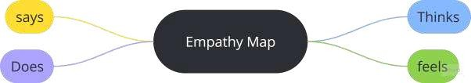

Optimizing User, Group, and Role Management with Access Control and Workflows

